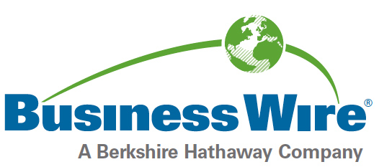

IBC2019: Free 100-word Profile Form

Deadline to submit your free profile is 12:00PM Eastern, Sept. 10, 2019.
Profiles will be distributed via Business Wire on Sept. 12, 2019.
Please complete and E-MAIL the form below to
tradeshow.profiles@businesswire.com

(Note: ONLY .doc format submissions will be processed – NO docx or pdfs)
Show Name: | IBC2019
Company:
Stand:
Ticker Symbol & Exchange:
PR Contact:
Phone:
E-mail:
Web:
Business Wire
Online Press Kit:
100-word Company description:

Note: Profiles are compiled alphabetically into one release & issued before the event opens. Please be sure to include accurate and up-to-date information in your profile; do not include information that should not be made available to media before the event starts.

Business Wire is the official news wire for IBC2019

For questions about press release distribution & online press kit services,
contact tradeshow@businesswire.com

